**STAT 477/STAT 577**

**HW 5**

**Neha Maddali**

1. Polling Data

a. Contingency Table

b. Mosaic Plot or Segmented Bar Graph

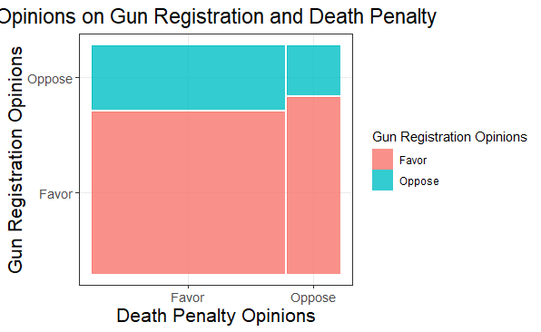

Interpretation: There is a difference in the height of the vertical segments within each combination of opinions on gun registration and the death penalty. This indicates a variation in the proportion of respondents favoring or opposing gun registration across different opinions on the death penalty.

c. Null Hypothesis: There is no association between opinions on gun registration and the death penalty.

Alternative Hypothesis: There is an association between opinions on gun registration and the death penalty.

Test Statistic: 4.82333

P-value: 0.02807705

Conclusion: There is evidence of an association between opinions on gun registration and the death penalty.

d. Estimated Correlation: -0.0607179

2. Tire Data

a. Contingency Table

b. Mosaic Plot

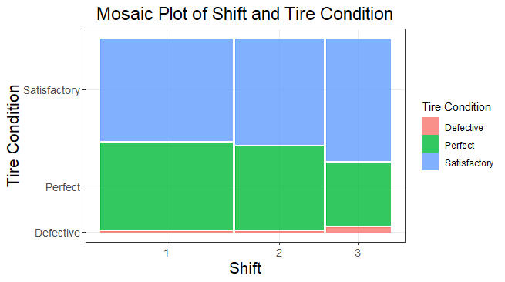

Interpretation: The amount of perfect condition tires decreases as the shift increases. The amount of defective tires increases as shift increases.

c. Why is a test of independence OK to use in this case?

This test is ok because the tires are selected randomly and we don’t know how many will be in each group beforehand. So we should use test of independence.

d. How would we need to change the data collection to use test of multinomial equality?

We would need to adjust group size before sampling. We could sample 150 tires from each shift.

e. Null Hypothesis: Tire condition and shift are independent.

Alternative Hypothesis: Tire condition and shift are not independent.

Test Statistic: 8.646696

P-value: 0.07056327

Conclusion: There is no significant evidence of an association between shift and the condition of the tire.

f. Estimated Cramer’s V: 0.09336181

3. Ability

a. Contingency Table

b. Mosaic Plot or Segmented Bar Graph

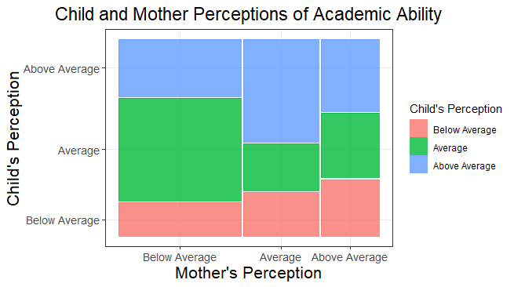

Interpretation: The vertical segments differ noticeably among the classes, suggesting a potential association between child and mother perceptions, indicating that the two variables are not independent.

c. Null Hypothesis: There is no association between child and mother perceptions of academic ability.

Alternative Hypothesis: There is an association between child and mother perceptions of academic ability.

Test Statistic: 17.21778

P-value: 0.001753395

Conclusion: There is significant evidence of an association between child and mother perceptions of academic ability.

d. Goodman-Krustal Gamma

More than Random Agreement?

Given that the confidence interval includes zero, the Goodman-Krustal Gamma suggests that there is no conclusive evidence of more than random agreement between mother and child perceptions of ability.